Ticket Creation, Allocation & Update
Design Specification & Functional Documentation

Document Name: Ticket Creation, Allocation & Update Design Specification & Functional Documentation
Version: 21.0
Prepared By: Engineering Team
Date: 06-02-2026
Status: Approved

1. Purpose
This document defines the functional and design specifications for Ticket Creation, Allocation and update within the application. It explains how users can create ticket through multiple channels and how authorized users can allocate those tickets through the application.

2. Scope
- Covers Ticket Creation via:
  - Email
  - Application
  - Chatbot (WhatsApp)
- Covers Ticket Allocation via Application only

3. Actors & Roles
3.1 Requester
• The requester is the individual who reports an issue or requests a service. While tickets can be created via email, application, or chatbot, the person creating the ticket may not always be the requester. In some cases, a ticket may be submitted by another individual on the requester’s behalf.
3.2 Technician / Track It User
- An authorized user responsible for handling service tickets.
- The technician can assign tickets to themselves or to other technicians and begin working on the assigned ticket.

4. Ticket Creation
Ticket can be created through three different channels. Regardless of the source, all tickets are stored in a common Ticket List with a unique Ticket ID.

4.1 Ticket Creation via Email
Trigger Condition
- An email is sent to trackit@caerusitconsulting.com in To or CC
Functional Rules
- Email must contain a unique subject line
Field Mapping
Email Field | Request Field
Subject | Title
Email Body | Description
Attachments | Attachments (if any)
System Behaviour
- System generates a unique Ticket ID
- Ticket is created automatically

4.2 Ticket Creation via Chatbot (WhatsApp)
Entry Point
- User selects Create Ticket option in WhatsApp chatbot
Chatbot Interaction Flow
- Bot asks for Ticket Title
- User provides title
- Bot asks for Ticket Description
- User provides description
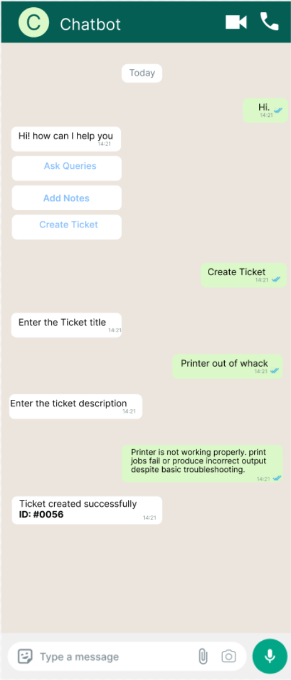
System Behaviour
- Bot validates inputs
- System generates a unique Ticket ID
- Ticket is created and stored
- Confirmation message with Ticket ID is sent to user

4.3 Ticket Creation via Application
User Flow
- User navigates to Ticket screen
- Click on + Create Ticket button
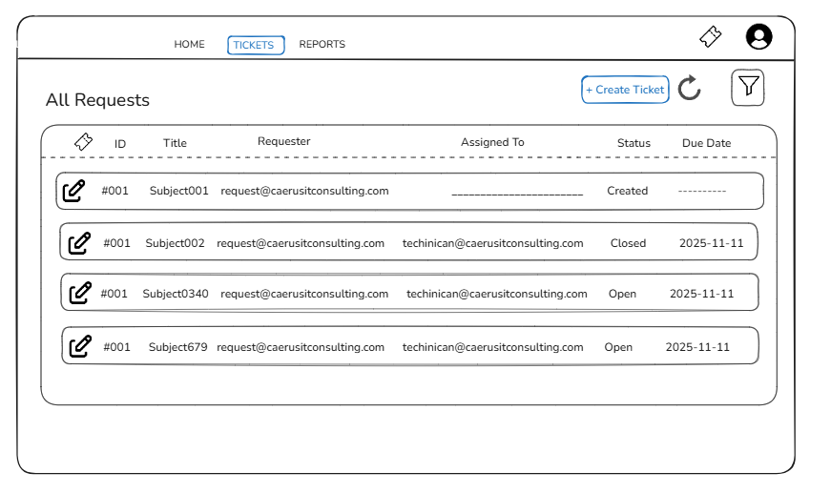
- User enters required details
- User clicks Create button

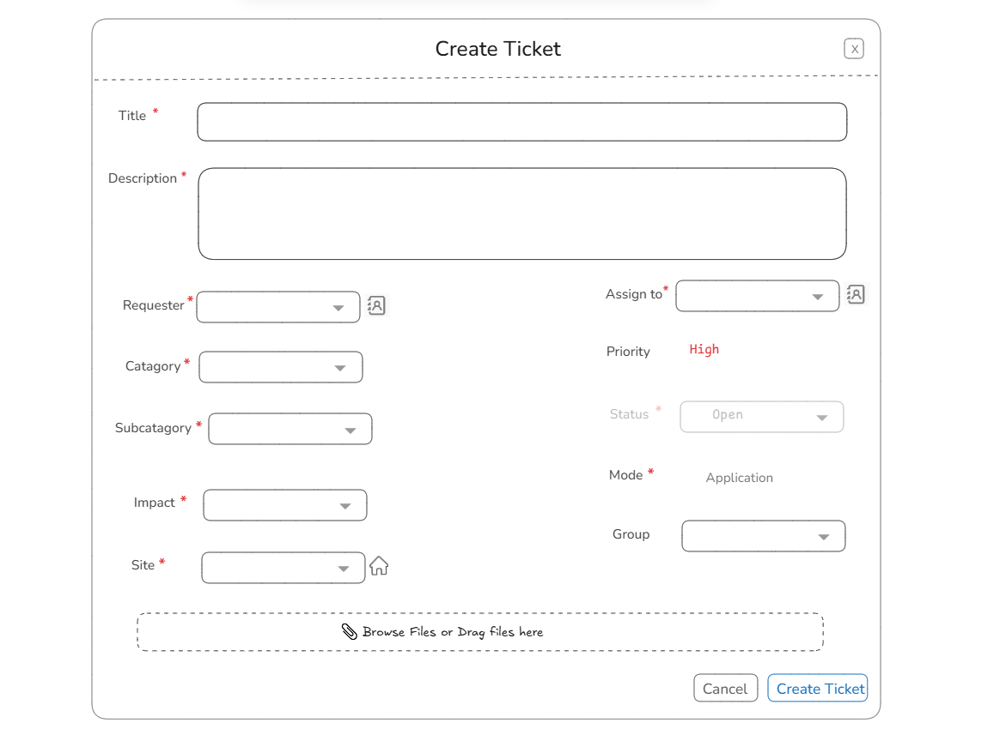

Field Name | Mandatory | Type / Behaviour
Title | Yes | Text field
Description | Yes | Text area
Requester | Yes | Selectable / Text field
Category | Yes | Dropdown
Subcategory | Yes | Dropdown
Impact | Yes | Dropdown
Site | Yes | Dropdown
Assign To | Yes | User selection
Priority | Auto | System calculated based on impact
Status | Yes (Auto) | System defined
Mode | Yes (Auto) | System defined
Group | No | Assignment field
Attachment | No | File upload

System Behaviour
- Validates mandatory fields
- Generates a unique Ticket ID
- Saves ticket in Ticket List
- Displays success confirmation to user

5. Ticket List & Visibility
Ticket Section
- All created tickets (created via Email, Application, Chatbot) appear in the Ticket tab as List
Visible Information
- ID
- Title
- Created Date
- Requester
- Status


6. Ticket Update & Allocation
6.1 Ticket Allocation (for tickets created via Chatbot or Email)
- User clicks on the Edit icon for a ticket (created via Chatbot or Email).
- A Form will be open (same fields as ticket creation form).
- Title and Description are auto populated.
- User fills all other mandatory fields (e.g., Assign To, Category, Subcategory, Impact, Site).
- User clicks Update Ticket.

6.2 Ticket Update (for modifying existing ticket details)
- User clicks on the Edit icon for the ticket to be updated.
- A Form will be open (same fields as ticket creation form), with all fields prefilled with existing ticket details.
- User modifies the necessary fields (e.g., Title, Description, Category, Subcategory, Impact, Site, Assign To).
- User clicks Update to save the changes.
6.3 Ticket Update / Allocation Preconditions
- Ticket update or allocation is only possible through the Application
- A valid Ticket ID must be selected

6.2 Ticket Allocation Form
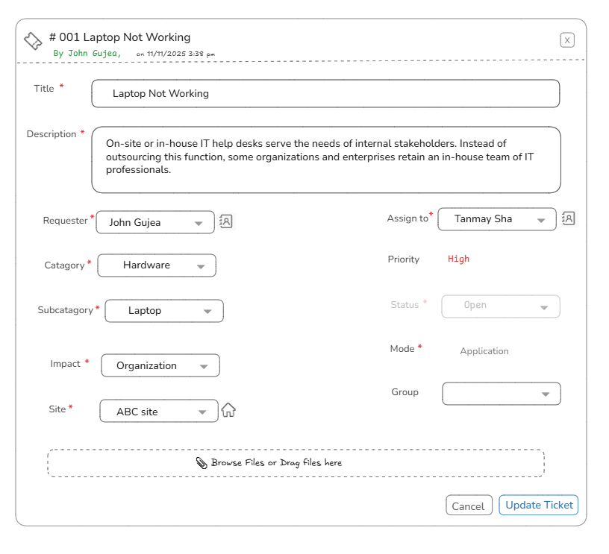

6.3 Ticket Allocation Flow
- User selects a ticket from Ticket List
- User Allocation form is displayed
- User fills all mandatory fields
- User clicks Update Ticket button

6.4 System Behaviour After Allocation
- When a user assigns a ticket to himself, the system automatically redirects the user to the Milestone tab.
- OR when a user accepts a ticket that is assigned to his queue, the system automatically redirects the user to the Milestone tab.
- Upon redirection, the system displays the “Create Milestone” modal dialog.
- Then the milestone flow will be continued.

7. Audit & Tracking
- All ticket and ticket actions are logged
- Includes:
  - Created by
  - Created date
  - Assigned user

10. Summary
This design ensures a unified ticket intake mechanism across Email, Application, and Chatbot, while maintaining controlled and structured ticket allocation through the application only. The approach improves traceability, accountability, and operational efficiency.

